**Backlog consists of overall features**

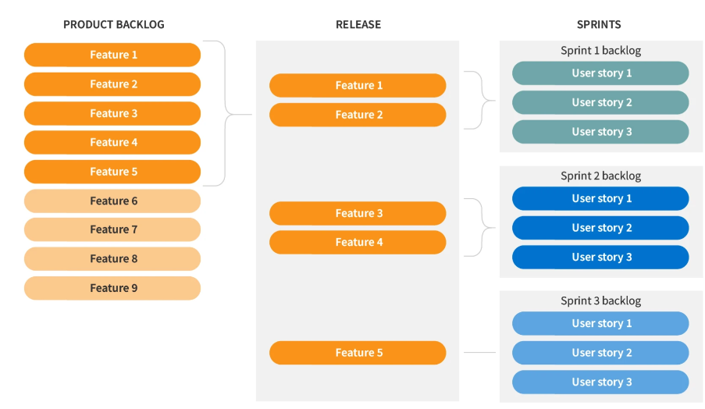

**Features can be further break into smaller user stories**

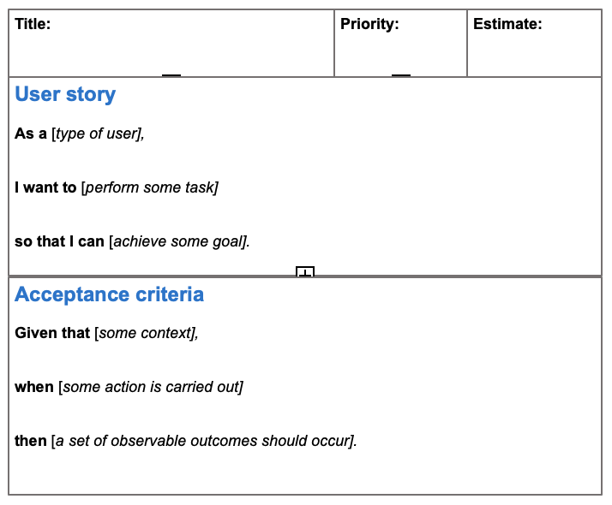

**Example of acceptance criteria**

|  |
| --- |
| **Scenario:** Forgot password   * **Given:** The user navigates to the login page * **When:**The user selects <*forgot password*> option * **And:** Enters a valid email to receive a link for password recovery * **Then:** The system sends the link to the entered email * **Given:** The user receives the link via the email * **When:**The user navigates through the link received in the email * **Then:** The system enables the user to set a new password |

<https://www.altexsoft.com/blog/acceptance-criteria-purposes-formats-and-best-practices/>